IDSF DRESS

REGULATIONS

These Regulations are part of the IDSF Competition Rules by reference in Rule 12.

Authority and Applicability

These Dress Regulations apply to all IDSF named events and according to the decision of the IDSF Annual General Meeting, form part of the national competition rules for all IDSF national members, except that IDSF national members may impose additional dress restrictions at their own discretion for national non-IDSF-named events.

The IDSF Presidium retains the authority to impose specific additional or general dress restrictions or otherwise amend or allow exemptions, for specific events.
.

GENERAL

- Dresses have to create Characteristic shape for each discipline (ST and LA) (shape area).
- Dresses have to cover the intimate parts of the dancers bodies (intimacy area).
- Dresses and make-up have to respect age and level of dancers.
- Using of religious symbols as decoration or decoration jewellery is not allowed (this does not apply to personal jewellery).
- The chairman can ask the competitor to remove an item of jewellery or dress if it presents danger to the dancer or to other competitors.
- It is allowed to dance in dresses for lower categories.

Good Taste Rule
Any use of material or colour or construction or other contrivance that gives the appearance of non compliance with these dress rules, even though there is no breach of the literal wording of these rules, will be a breach of these rules if so determined by the Chairman of Adjudicators.

SANCTIONS

If a couple is not dressed in accordance with this Dress Regulation and receives a warning from the Chairman of adjudicators, they have to comply with the regulation or face disqualification IMMEDIATELY BY THE CHAIRMAN of the IDSF Sports Director, if present. The presidium can impose additional sanctions including suspension from competitions for repeat offenders.

DEFINITIONS OF TERMS

No restriction (NR) – there are no restrictions in this matter

Not allowed (NA),
Only allowed (OA),

Intimacy area (IA) – body zones, which have to be covered by non transparent materials or transparent materials lined with non transparent materials. If skin colour is used, it has to be SwD.
.
For Female partner:
- tangas are NA.
- skin colours panties are NA.
- Breasts have to be covered
- the distance between bra cups has to be less than 5 cm.

Shape area (SA) – minimum area which has to be covered. Transparent materials are allowed in these areas, any colour is allowed.
Basic material – creates shape of the dress
- with light effects (metallic, glitter, sequined, …)
- without light effects

Decoration – anything fixed on the basic material, hair, skin:
- with light effects (rhinestones, sequins, beads, pearls, …)
- without light effects (feathers, flowers, bows, fringe, lace applications, ribbons, …)
Tie clips, studs, cufflinks, buckles are not thought of as decorations.

Hip Line (HL) – panties top line (how low)
- straight horizontal line, top of line between buttocks muscles (intergluteal line) must not be visible.
Panty Line (PL) – panties bottom line (how high)
  - back side – whole buttocks are covered
  - in the front – follows line between flexed leg and body

The distance between HL and PL on the side has to be more than 5 cm

Man’s Top Opening Point (TOP) – point, to which top or shirt can be opened
- centre of the belt buckle or centre of the trousers top line

Colours
- black only ( Bo )
- black (B) – means black and midnight blue
- white (W)
- skin colour (S) –equal to the colour of the dancer’s skin during the competition (with tan)
- skin colour with decoration (SwD)
- any colour (C) – any colour inc. mixed colours
- any colour except skin colour (CnS)
- one colour except skin colour (C1nS)

Long Sleeves/ed (LS) – length to the wrist, rolled up sleeves are NA

Make-up – includes face make-up, artificial tan, artificial nails, artificial eye lashes.

Decoration jewellery – a jewellery designed to be a part of a dance dress

DRESS SPECIFICATION

1. DANCE DRESS – Only Allowed
Partner | Male |  |  |  |  |  | Female
Disc. | ST |  |  |  |  | LA | ST |  |  |  | LA
Juvenile | W LS shirt  Bo trousers  Bo tie/bow tie |  |  |  |  |  | W blouse leotard or T shirt  Bo skirt  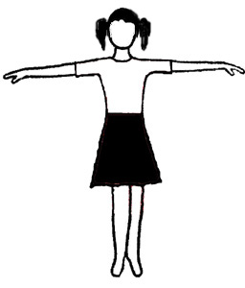 |  | simple C1nS dress + panties  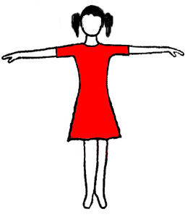 |  |  | C1nS leotard with same colour skirt attached  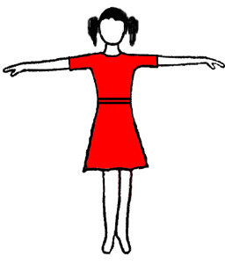
Juvenile | cuts and details – see appendix I |  |  |  |  |  | cuts and details – see appendix II
Junior I | W LS shirt  Bo vest  Bo trousers  W/Bo tie/bow tie  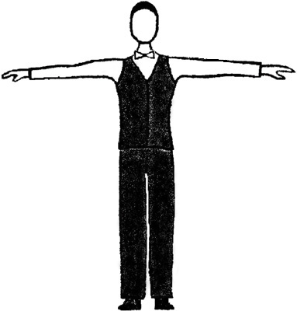 |  |  |  |  | W/Bo LS top/shirt  Bo vest –opt.  Bo trousers  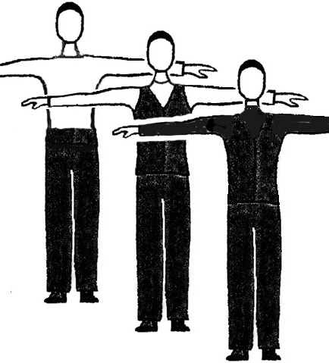 | Competition dress  JI –CnS  others – C  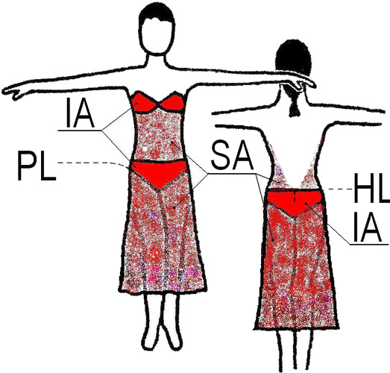  two piece dresses NA |  |  | Competition dress  JI –CnS  others – C  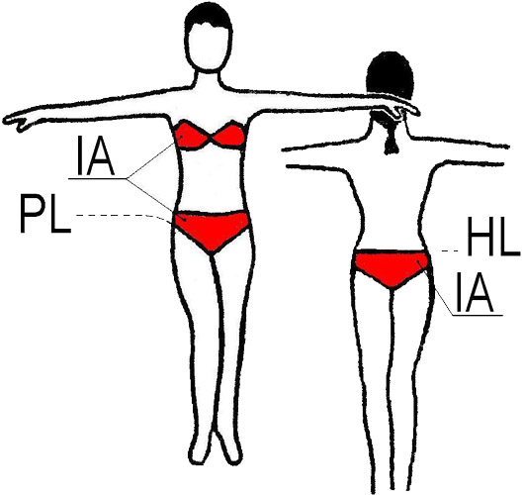  Top and trunk must not be only bikini
Junior II  Youth  Adult  Senior | B Jacket suit  (B trousers  B jacket  W shirt  B tie  Or W tail shirt  W bow tie) |  | B Tail suit  (B trousers  B tails  W waistcoat  W tail shirt  W bow tie) |  |  | C Shirt/Top  CnS trousers  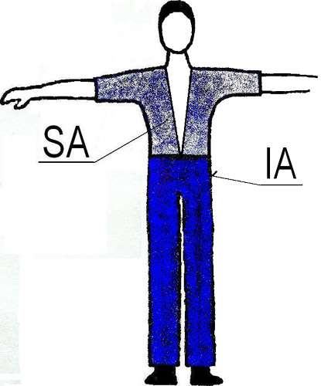
Junior II  Youth  Adult  Senior | 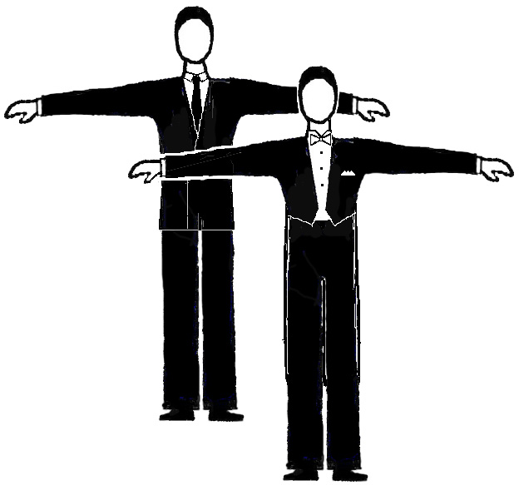
2. DECORATIONS, LIGHT EFFECTS
Partner |  | Male |  |  |  |  |  | Female
Disc. |  | ST |  | LA |  |  |  | ST |  |  | LA
Juv |  | Any decorations – NA  Basic materials with light effects - NA |  |  |  |  |  | Any decorations – NA  Basic materials with light effects - NA
Jun I |  |  |  |  |  |  |  | Decoration with light effects – NA  (Decoration without light effects are allowed).  Basic materials with light effects – NA
Jun II – Sen |  | NR

3. SHOES, SOCKS, TIGHTS
Partner |  | Male |  |  |  |  |  | Female
Disc. |  | ST |  |  | LA |  |  | ST |  |  | LA
Juv |  | Heel: has to be max 2,5 cm  B socks have to be used |  |  |  |  |  | Heel: block, has to be max 3,5cm  C short socks are allowed  Tights: skin colour - OA, mesh - NA
Jun I |  | Shoes: NR |  |  |  |  |  | Heel: has to be max 5 cm  short socks are allowed  tights: mesh - NA
Jun II – Sen |  |  |  |  |  |  |  | NR

4. HAIRSTYLES
Partner |  | Male |  |  |  |  |  | Female
Disc. |  | ST |  |  | LA |  |  | ST |  |  | LA
Juv |  | If the hair is long it has to be worn in a ponytail |  |  |  |  |  | Decoration and coloured hairspray - NA
Jun I |  |  |  |  |  |  |  | Decoration with light effects and coloured hairspray – NA  (Decoration without light effects are allowed)
Jun II – Sen |  |  |  |  |  |  |  | NR

5. MAKE-UP
Partner |  | Male |  |  |  |  |  | Female
Disc. |  | ST |  |  | LA |  |  | ST |  |  | LA
Juv, Jun I |  | Make-up - NA
Jun II – Sen |  | NR

6. DECORATION JEWELLERY (not personally jewellery)
Partner |  | Male |  |  |  |  |  | Female
Disc. |  | ST |  |  | LA |  |  | ST |  |  | LA
Juv |  | Decoration jewellery - NA
Jun I |  | Decoration jewellery with light effects – NA  (Decoration jewellery without light effects are allowed)
Jun II – Sen |  | NR
Appendix 1: Juveniles Male Dress

Shirt:
- plain, white long sleeved, ready to wear shirt – OA
- shiny or patterned materials – NA, cotton or polycotton preferred
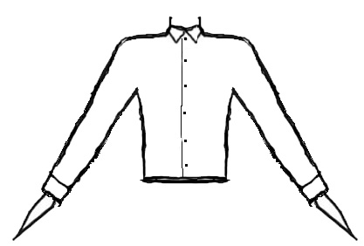
- wing collar - NA
- rolled up sleeves - NA.
- has to be tucked in.

Appendix 2: Juveniles Female Dress

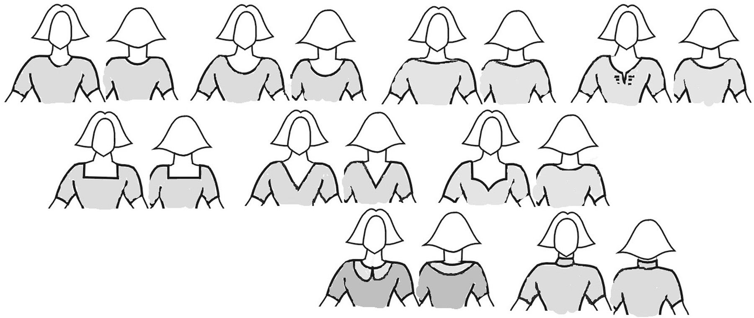
- Necklines – allowed cuts, others - NA:

- Sleeves – allowed cuts, others - NA:
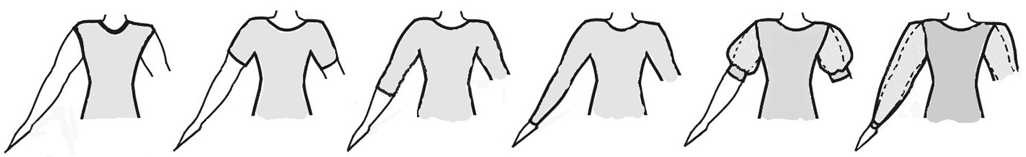

- Skirts:
- plain or pleated, made of minimum 1 to maximum 3 half circles - OA, one simple circular underskirt allowed, bigger underskirt - NA.
- frills on the skirt or the underskirt, boning, soft boning or fishing line used in the hem of the skirt – NA
- length must not be more then 10 cm above the knee and not longer than just below the knee cap.
- allowed cuts, others - NA:
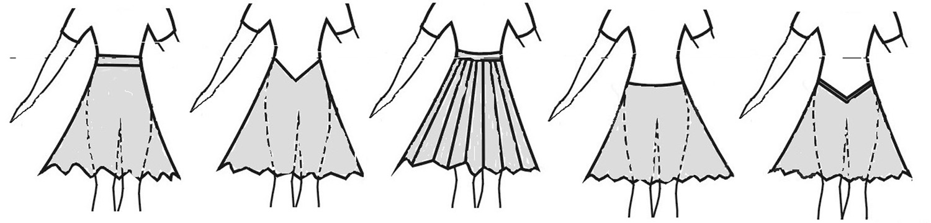

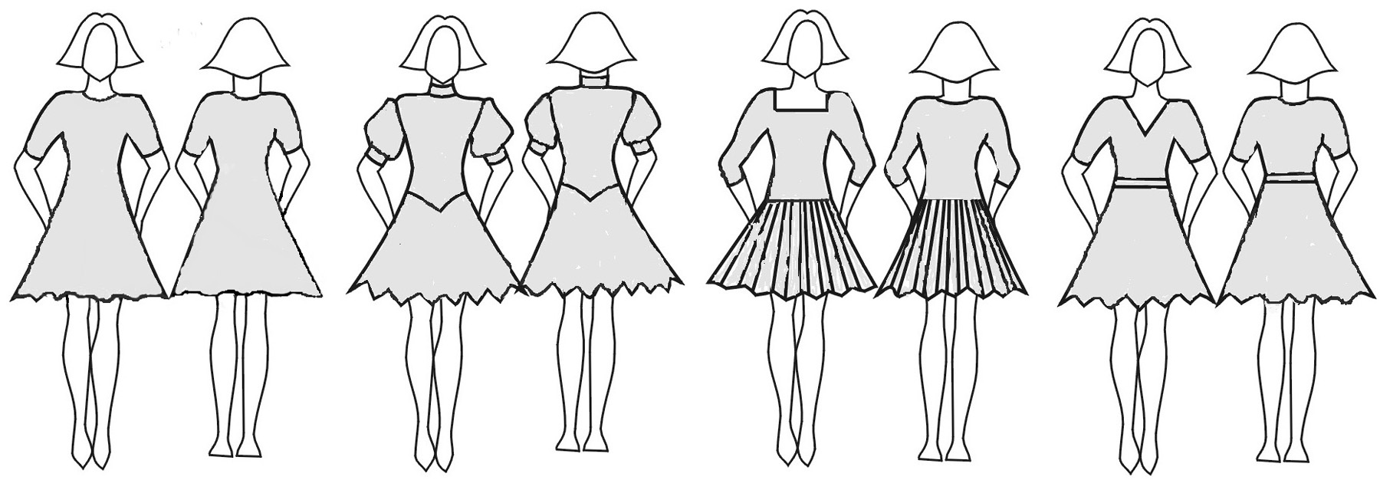
Examples:

